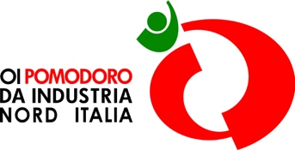

**Giuseppe Romanini elected President of the  
OI Pomodoro da Industria Nord Italia for the 2025-2027 term**

*Parma, December 9, 2024* - Giuseppe Romanini is the new President of the OI Pomodoro da Industria Nord Italia, the Interbranch Organization that brings together all POs (Producer Organizations) and processing companies in northern Italy. The new President was elected during the OI Assembly held this morning in Parma at the Interbranch Organization's headquarters, succeeding Tiberio Rabboni, who has led the OI Pomodoro da Industria Nord Italia since 2016.

Giuseppe Romanini is a former member of the Italian Parliament and a member of the Agriculture Committee in the Chamber of Deputies during the VXII legislature, he was an assessor of the Province of Parma, Mayor of the Municipality of Collecchio (Pr) and President of the Arrigo Boito Conservatory of Music in Parma.

“*I would like to thank the OI members for the trust they have placed in me* – says **Giuseppe Romanini**, the **newly elected President of the OI Pomodoro da Industria Nord Italia** –. *I am committed to the Interbranch Organization with the aim of strengthening and uniting a supply chain, that is so important for northern Italy and for the entire country, especially after a particularly challenging campaign such as that of 2024. We must work for greater stability in the supply chain, to reduce the risks of market fluctuations and seasonal difficulties caused also by climate change. The OI must be a place for transparent dialogue, capable of promoting long-term stability and growth. Respect for common rules and dialogue must be the foundation from which we begin to address the challenges of the sector and build a virtuous system of relationships that will enable the supply chain to grow in the coming years*.”

During the OI Assembly, the two **Vice-Presidents** were also appointed: **Bruna Saviotti** was re-elected as Vice-President for the processing side and **Alessandro Piva** replaces Luigi Sidoli as Vice-President for the agricultural side. Moreover, during the Assembly, it was also elected the new Board with paritetic representation of the agricultural and industrial parts.

Press Office OI Pomodoro da Industria Nord Italia

Veronica Fumarola  
Tel. +39 389 5512745

stampa@oipomodoronorditalia.it